**Department of Information Systems and Cyber Security University of Texas in San Antonio**



IS 3413: Telecom and Networking-001, Fall, 2022

Name: Daniel Cook  
UTSA ID: dhz799  
Email address: *danielwcook5@gmail.com*

Lab Assignment: Lab: M04 – Data Link Addressing  
Date Due: 9/24/2022  
Date Submitted: 9/24/2022

Section A, Question 1:. Provide a semi-anonymous version of your Ethernet or WiFi MAC address (as determined in the first part of the lab) by listing the first three bytes followed by “-XX-XX-XX”.

Physical address is 04-D4-C4-xx-xx-xx.

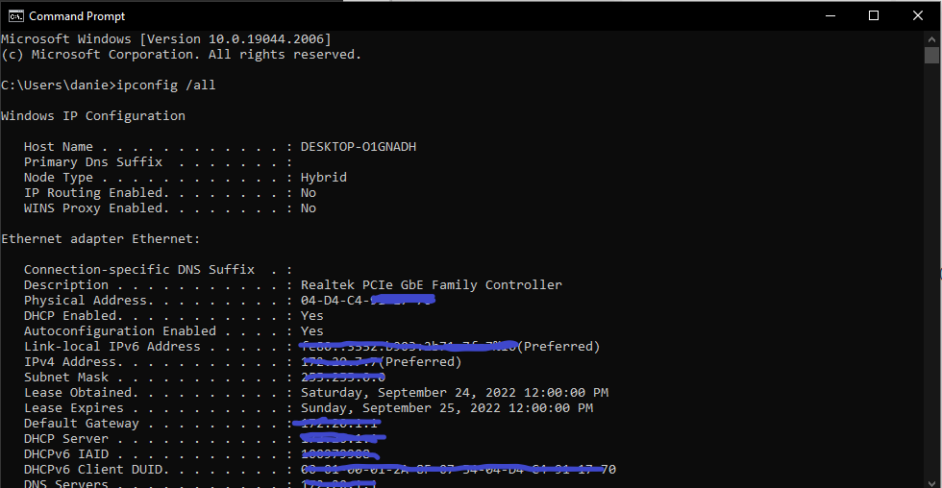

Section A, Question 2: Provide the MAC address of the network adapter which is the source of the traffic sent in the first packet of the file examined with Wireshark.

The MAC address from the source is (00:04:e2:22:5a:03).

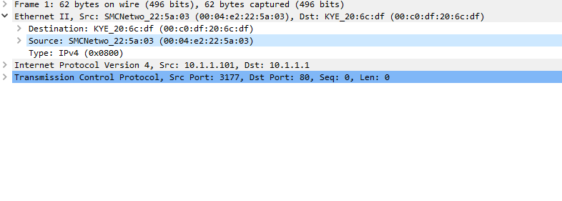

Section A, Question 3: Provide the MAC address of the network adapter which is the destination of the traffic sent in the first packet of the file examined with Wireshark.

The MAC address from the destination is (00:c0:df:20:6c:df).

